Market Intelligence Research Brief
Student Name: Chenlu Liu
Date: 24 September 2026
Topic/Company: B2B SAAS Competitive Landscape – Market Entry Intelligence

Business Question
Should we enter (or expand within) the B2B SaaS market in 2026, and if so, which segments, models, and geographies offer the best risk-adjusted opportunity?
DIMENSION | DETAIL
Decision-Maker | Chief Strategy Officer / Chief Product Officer evaluating go/no-go market entry and investment allocation
Scope | Global B2B SaaS across all major application categories (CRM, ERP, cybersecurity, AI/ML, collaboration, analytics, HR/HCM, vertical SaaS); 2024–2032 projections with primary focus on 2025–2026
Data Sources | Internal dataset (500 B2B SaaS companies — descriptive fields only) + 5 external research reports (market sizing, concentration, pricing evolution, growth categories, risks/headwinds)
Methodology | Cross-source triangulation — every insight requires at least one [Internal Dataset] and one [External Research] data point, with explicit source tagging
Key Constraint | Internal dataset contains no revenue, ARR, churn, or pricing data; all financial figures are anchored to external research
SPACE:
us-west-2.quicksight.aws.amazon.com/sn/account/UdacityQuicksightLab/spaces/c19fb809-c459-4131-9e98-4cfae656e574

1. Research Objective
Briefly describe the business question or decision this market intelligence is intended to support.
Objective: Determine whether to enter (or expand within) the B2B SaaS market in 2026, identifying which segments, pricing models, and geographies offer the best risk-adjusted opportunity for C-suite go/no-go investment decisions.

2. Scope of Research
Define what was included and excluded in this research.
- Markets or industries covered: Global B2B SaaS across all major application categories — CRM, ERP, cybersecurity, AI/ML, collaboration, analytics, HR/HCM, and vertical SaaS
- Competitor types included: Hyperscalers (Microsoft, AWS, Google), pure-play SaaS leaders (Salesforce, ServiceNow, Workday), AI-native startups, and niche/vertical SaaS providers across 500 companies in the internal dataset
- Timeframe considered: 2024–2032 projections with primary focus on 2025–2026 market conditions
- Key constraints: Internal dataset contains only descriptive fields (name, URL, type, category, keywords, description) — no revenue, ARR, churn, headcount, or funding data; all financial figures anchored to external research reports; research compiled primarily before September 2026 Fed rate increase

3. Research Approach
Summarize how AI-assisted research was conducted.
- Types of questions asked: Market sizing and growth trajectory questions; segment-level concentration and competitive dynamics; pricing model evolution and adoption rates; unit economics benchmarks (CAC, NRR, Magic Number); geographic growth differentials; AI adoption prevalence and impact
- How research effort was prioritized: Cross-source triangulation methodology — every insight required at least one [Internal Dataset] and one [External Research] data point with explicit source tagging; highest priority given to signals with convergence across 3+ independent sources
- Tools used within Amazon Quick Suite: Quick Research (5 external research reports on market sizing, concentration, pricing evolution, growth categories, and risks/headwinds), Amazon Q Chat Agent (synthesis and analysis), Spaces (Market Intelligence — B2B SaaS space with 500-company dataset.csv and indexed research PDFs), Internal Dataset analysis (keyword frequency, category distribution, business model classification)

4. Key Market Insights
List 3–5 synthesized insights relevant to leadership decision-making.

Insight 1: AI/ML SaaS Is the Runaway Growth Category (~35% CAGR)
- Insight Summary: AI/ML is the dominant growth engine in B2B SaaS, with AI-as-a-Service projected to grow from $20.26B (2025) to $91.20B (2030) at 35.1% CAGR — more than double any other category.
- Supporting Evidence or Signals: 51%+ of the 500 companies in the internal dataset reference AI/ML keywords [Internal Dataset]; enterprise AI spending surged 6× to $13.8B in 2024; 46% of companies report AI productivity at scale; 35% of teams have already replaced at least one SaaS product with an AI-built tool [External Research].
- Why This Insight Matters: AI is no longer a feature add-on — it is the primary growth engine reshaping every SaaS category. Any market-entry strategy that does not embed AI-native capabilities from day one risks irrelevance before first renewal.

Insight 2: Market Is Moderately Concentrated but Segment-Level Variation Is Extreme (HHI 500–600)
- Insight Summary: Overall B2B SaaS market concentration is moderate (HHI 500–600), but segment-level variation is extreme — HR/HCM top-3 vendors hold 77% share while cybersecurity top-3 hold only ~15%.
- Supporting Evidence or Signals: "Software" = 239 companies (47.8%); cybersecurity = 21 (4.2%) yet 70 (14.0%) reference security keywords [Internal Dataset]; Microsoft $168.9B cloud revenue vs. Salesforce $41.5B; HR/HCM top-3 hold 77% share vs. cybersecurity top-3 at ~15% [External Research].
- Why This Insight Matters: Fragmented segments (cybersecurity, marketing automation) represent entry opportunities with lower incumbent lock-in. Cybersecurity's combination of fragmentation, non-discretionary demand, and regulatory mandates makes it the most defensible entry point for new players.

Insight 3: Hybrid Pricing Is the New Default (27% → 41% in 12 Months)
- Insight Summary: Hybrid pricing adoption surged from 27% to 41% in just 12 months, with hybrid models delivering 21% median revenue growth compared to 14% for pure subscription.
- Supporting Evidence or Signals: Dataset includes both traditional subscription models (Salesforce, Atlassian) and usage/AI-native models (OpenAI, Hugging Face); 34.6% hybrid B2B+B2C business models [Internal Dataset]; 85% of SaaS companies implementing usage-based pricing; hybrid models achieve 21% median revenue growth vs. 14% pure subscription [External Research].
- Why This Insight Matters: New entrants must build metering and billing infrastructure from inception. Seat-based pricing launched in 2026 is a strategic liability. The 21% growth advantage for hybrid models is a non-negotiable design decision.

Insight 4 : Unit Economics Have Deteriorated to Historically Hostile Levels
- Insight Summary: SaaS unit economics have deteriorated sharply — CAC surged ~222%, Magic Number collapsed from 0.54× to 0.36×, and NRR declined from 110.5% to 107.1%, while VC funding collapsed 67%.
- Supporting Evidence or Signals: 500 companies spanning seed to enterprise concentrated in competitive horizontal categories (Software: 47.8%) [Internal Dataset]; CAC surged ~222%; Magic Number collapsed 0.54× → 0.36×; NRR declined 110.5% → 107.1%; VC funds collapsed 67% (1,609 → 537); 65% of Q1 2026 VC capital flowed to 4 AI mega-companies [External Research].
- Why This Insight Matters: The capital environment is structurally hostile to non-AI-native startups. Product-led growth and capital efficiency are survival imperatives, not differentiators. Paid acquisition at current CPMs (LinkedIn up ~185%) is a near-certain path to cash depletion.

Insight 5 : Asia-Pacific Is the Highest-Growth Geographic Frontier (AI at 43% CAGR)
- Insight Summary: APAC represents the fastest-growing geographic opportunity with AI SaaS at 43% CAGR and analytics at 28.1% CAGR, significantly outpacing North American growth rates.
- Supporting Evidence or Signals: Dataset skews heavily North American/English-language with minimal APAC representation — flagging curation bias [Internal Dataset]; APAC SaaS market ~$85.7B (2025) at 15.3% CAGR; APAC AI CAGR 43% vs. North America 35%; APAC analytics CAGR 28.1% vs. NA 15% [External Research].
- Why This Insight Matters: Organizations focused exclusively on North America miss the fastest-growing opportunity. APAC warrants dedicated regional strategy as a Phase 2 growth vector, not an afterthought.
(Copy and paste additional insight blocks if needed)

5. Visual Evidence (Optional but Recommended)
Reference any charts, dashboards, or visualizations used to support the insights.

Chart A — Industry Category Distribution:
Chart Type: Horizontal Bar
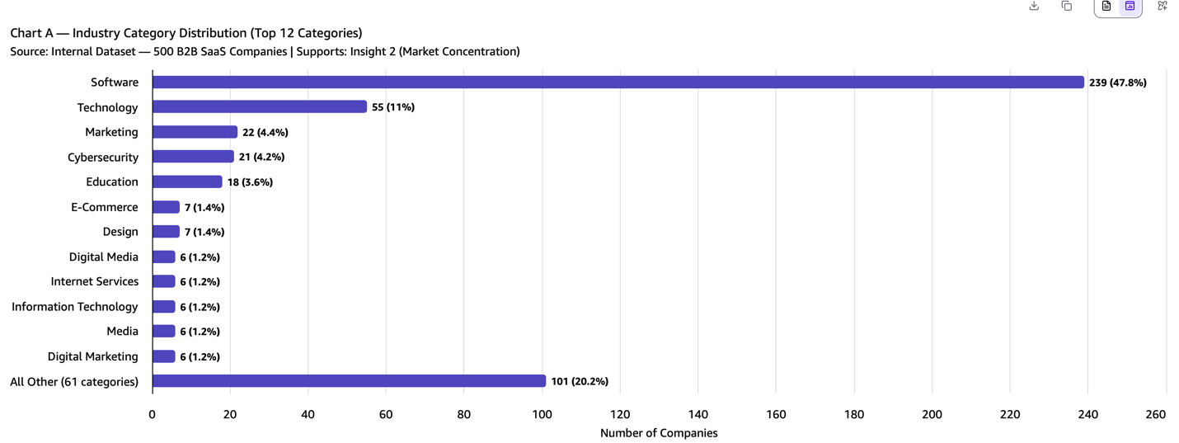
- What the visualization shows: Distribution of the 500 companies across industry categories (Software, Technology, Cybersecurity, Analytics, Marketing, etc.), revealing that "Software" dominates at 47.8% while cybersecurity (4.2%), healthcare (0.8%), and financial services (0.6%) are under-represented.
- How it supports the insight: Supports Insight 2 (Market Concentration) by visually demonstrating the extreme category imbalance and identifying potential curation bias in the dataset.

Chart B : Business Model Distribution ( 500 Companies)
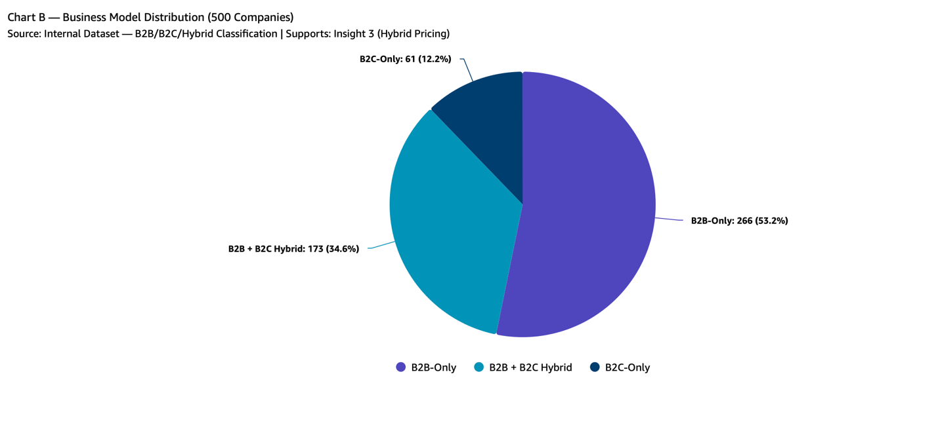
- Chart Type: Pie/donut chart
- What the visualization shows: Business model split across the 500 companies — B2B, B2C, and hybrid B2B+B2C models, showing 34.6% operate hybrid models alongside pure B2B and B2C players.
- How it supports the insight: Supports Insight 3 (Hybrid Pricing) by showing the prevalence of hybrid business models in the dataset, reinforcing external research on the shift away from pure subscription pricing.

Chart C : Top 15 keyword Frequencies Across 500 Companies
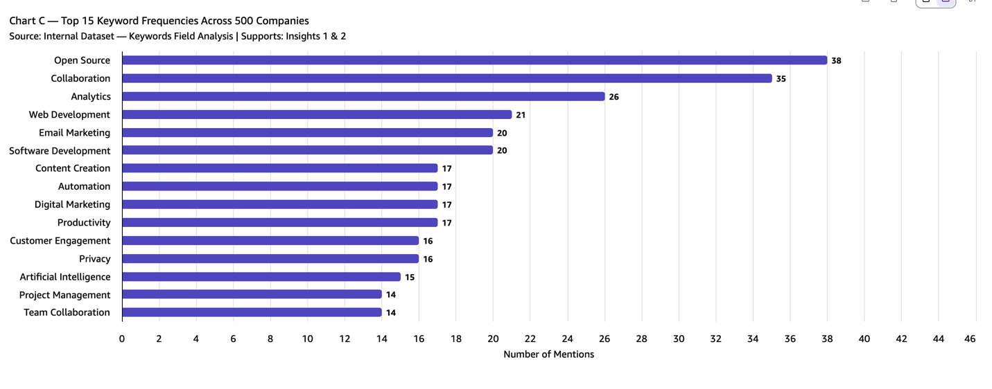
- Chart Type: Horizontal bar chart (Top 15)
- What the visualization shows: Frequency of top keywords across the 500 companies, with AI/ML-related terms appearing in 51%+ of company descriptions, followed by security, analytics, cloud, and automation keywords.
- How it supports the insight: Supports Insight 1 (AI/ML Growth) by quantifying the dominance of AI/ML signals across the competitive landscape and showing the breadth of AI integration across SaaS categories.

6. Confidence Assessment
Evaluate the reliability of the insights using the criteria below.
- Source quality: Mixed quality across sources. Insights #1 and #2 draw on high-quality sources (McKinsey, Gartner, MarketsandMarkets, public earnings filings, DOJ HHI methodology combined with internal dataset analysis). Insights #3 and #4 rely on medium-high quality sources (Growth Unhinged surveys n=240+, Vertice, Metronome n=100, Crunchbase VC data). Insight #5 has medium source quality with fewer APAC-specific research firms available for validation.
- Consistency across sources: Strong consistency for Insights #1–#4, with 3–4+ independent sources converging directionally. Insight #5 has moderate consistency with fewer cross-validation sources available for APAC-specific claims. No major contradictions detected between internal dataset patterns and external research findings.
- Timeliness of information: Insights #1–#4 are based on current data (2025–Q1 2026). Insight #5 relies on a moderate 2024–2025 data base. Key caveat: the "SaaSpocalypse" (Feb 3, 2026, >$1T market cap erased) and September 2026 Fed rate increase occurred after much external research was compiled, meaning current conditions may be more negative than projections reflect.
- Overall confidence level: Medium-High — supported by convergence across 5 internal dataset analyses and 5 external research reports; tempered by (1) absence of company-level financial data, (2) $127B spread across research-firm market estimates, and (3) limited APAC cross-validation. Insights #1 and #2: High confidence. Insights #3 and #4: Medium-High confidence. Insight #5: Medium confidence.

7. Limitations and Risks
Document known gaps, assumptions, or areas of uncertainty.
- Missing data: The 500-company internal dataset contains only descriptive fields — no revenue, ARR, churn, headcount, or funding data. Every financial figure is anchored exclusively to external research. No geographic field exists in the dataset, creating an APAC blind spot.
- Conflicting signals: Market sizing estimates for 2025 range from $370B to $497B (a 34% spread) depending on methodology and source. Use the midpoint range ($420–$440B) as the planning assumption. Additionally, whether AI-driven NRR compression (110.5% → 107.1%) will stabilize or accelerate is unknown due to insufficient longitudinal data.
- Potential bias or ambiguity: Curation bias — "Software" is over-represented at 47.8% while healthcare (0.8%), financial services (0.6%), and legal (0.2%) are under-represented. Survey respondent bias — pricing and unit economics data derive from surveys (n=100–240) that may skew toward AI-forward early adopters. Temporal snapshot risk — the "SaaSpocalypse" and September 2026 Fed rate increase occurred after much external research was compiled, meaning current conditions may be more negative than reported.

8. Strategic Implications
Explain how leadership should interpret and use this intelligence.
- Segment Selection: Prioritize AI-native products in fragmented segments — cybersecurity (top-3 share: ~15%) and analytics (24.5% CAGR) offer structural entry advantages with non-discretionary demand.
- Product & Pricing Strategy: Any new initiative must be AI-native from inception with hybrid metering and billing infrastructure. The 21% revenue growth advantage for hybrid models vs. 14% for pure subscription is decisive.
- Go-to-Market: Shift from paid acquisition to product-led growth, community-driven adoption, and land-and-expand motions; target CAC payback <14 months.
- Geographic Expansion: Evaluate APAC as Phase 2 (AI CAGR: 43%; analytics CAGR: 28.1%) with dedicated regional strategy, partnerships, and localization.
- Highest-Priority Next Step: Launch a detailed competitive due-diligence assessment of the cybersecurity and AI-native SaaS segments, incorporating financial data, customer interviews, win/loss analysis, and pricing analysis to convert directional insights into specific investment or build decisions.

What should not be concluded from this research?
- Optimal vertical vs. horizontal positioning cannot be determined — the internal dataset lacks granularity to validate which specific verticals (healthcare, fintech, construction) offer the best customer fit. Customer discovery and win/loss analysis are required.
- Capital requirements for viable market entry are not established — the deteriorating unit economics data identifies the problem but does not quantify the minimum funding threshold for breakeven under 2026 conditions. A financial model with sensitivity analysis is needed.

9. Summary for Leadership
Provide a concise executive summary (5–7 sentences).
Executive Summary:
The B2B SaaS market is valued at approximately $390–$497 billion in 2025, projected to reach $470–$634 billion in 2026, with AI integration serving as the dominant growth catalyst at ~35% CAGR — more than double any other category. Cybersecurity stands out as the most defensible market entry point, with the top 3 vendors holding only ~15% market share compared to 77% in HR/HCM, offering fragmentation combined with non-discretionary demand. Hybrid pricing has become the industry default (27% → 41% adoption in 12 months), delivering a 21% median revenue growth advantage that makes metering infrastructure a non-negotiable design decision for any new entrant. However, unit economics are at historically hostile levels — CAC up 222%, Magic Number at 0.36×, and 65% of Q1 2026 VC capital concentrated in just 4 AI mega-companies — making product-led growth and capital efficiency survival imperatives. Overall confidence in these findings is Medium-High, supported by convergence across internal and external sources but tempered by the internal dataset's lack of financial metrics and a $127B spread in market size estimates. The highest-priority next step is a focused competitive due-diligence assessment in cybersecurity and AI-native SaaS to convert directional intelligence into specific investment decisions.

